HIV in African Youth

A Call to Action

MSBA 350E - Healthcare Analytics

Name: Jad Shahine

Date: June 14th, 2023

Table of Contents

I. Introduction: 3

A. HIV Briefing 3

B. Literature Review 3

C. Objective 3

II. Methodology 4

A. Data Source & Description: 4

B. Data Cleaning: 4

C. Data Exploration: 4

D. Limitations: 4

III. Results 5

IV. Recommendations 7

V. References 8

List of Figures

Figure 1 Total Deaths by Cause per Year 5

Figure 2 HIV Death Rates Per Year 5

Figure 3 New HIV Infection Rate per 100,000 Uninfected People 5

Figure 4 Gender Share of HIV Infection in African Countries per Year 6

Figure 5 Mother to Child HIV Transmission Rate in Africa 6

Figure 6 Prevention of Mother-Child Transmission Around the World 6

Figure 7 HIV Prevention Knowledge Among Young People in Africa 7

Figure 8 Share of People (15-49 Years Old) Who Used a Condom 7

# Introduction:

## HIV Briefing

HIV (Human Immunodeficiency Virus) is a viral infection that primarily affects the immune system. It weakens the body's ability to fight off infections and diseases, making individuals more susceptible to various illnesses. HIV is transmitted through the exchange of certain body fluids such as blood and breast milk. The origins of HIV can be traced back to the late 19th to early 20th century in Central and West Africa. The virus is believed to have originated from chimpanzees and was transmitted to humans through hunting and the consumption of chimpanzee meat, particularly through contact with infected blood. As of 2023, there is no cure for HIV; individuals who contract the virus will have it throughout their lives. However, with appropriate medical care, HIV can be managed effectively. People living with HIV and receiving antiretroviral therapy (ART) can lead long and healthy lives, while also taking measures to protect their partners from the transmission of the virus. A significant number of individuals experience flu-like symptoms within 2 to 4 weeks after contracting HIV. These symptoms can last for a few days or extend for several weeks. However, it is important to note that having these symptoms alone does not confirm an HIV infection, as other illnesses can also produce similar symptoms. It is possible for some people to have no symptoms at all. Consequently, the only definitive way to determine if one has HIV is by undergoing testing.

## Literature Review

Globally, HIV/AIDS remains a significant health challenge, resulting in a considerable number of deaths exceeding 39 million to date, and a current population of over 36 million individuals living with HIV and approximately 2 million people acquiring HIV infection each year (Pandey & Galvani, 2019). The infection rate remains high despite the advancements in ART and treatment-as-prevention programs worldwide. The significant increase in access to ART, going from 2.98 million people in 2006 to 21.8 million in 2017, was accompanied by a noteworthy 51% reduction in HIV mortality. Whereas the yearly infection rate decreased only by 17% during 2007–17 (Pandey & Galvani, 2019). Moreover, Liu et al. (2014) concluded that the transmittal rate is 0.92 per 100 HIV-negative persons whose partner is taking ART compared to 2.45 per 100 HIV-negative persons whose partner is not taking ART.

This implies that ART is effective at lowering the mortality of HIV as well as the likelihood of transmisstion. Thus the challenge was not only discovering an effective treatment but also ensuring its accessibility to those in need.

According to Dwyer-Lindgren et al. (2019), Sub-Saharan Africa bears the greatest burden of HIV as it comprises only 12% of the global population, yet accounts for over 70% of worldwide infections. If successful HIV prevention measures are implemented in sub-Saharan Africa, it can have a significant impact on the global HIV burden. Despite progress in expanding access to antiretroviral therapy, sub-Saharan Africa accounted for 74% of the 1.5 million AIDS-related deaths in 2013 (Kharsany & Karim, 2016).

When it comes to HIV, it is evident that Africa bears the heaviest burden, and among the most affected are African children and adolescents. Unicef's report from 2021 highlights that tuberculosis, an infection whose risks are heightened in HIV-positive people, and AIDS rank as the second and third leading causes of death in Africa, respectively. These diseases claim the lives of 24 individuals per 100,000, with children and adolescents being particularly vulnerable to their devastating impact.

## Objective

* Assess the prevalence of HIV among children and youth in Africa.
* Try and identify the key factors contributing to the high rates of HIV infection and mortality among children and youth in Africa.
* Identify gaps in knowledge, awareness, and accessibility related to HIV prevention and treatment among children and youth in Africa.

# Methodology

## Data Source & Description:

The basis of all analysis is the dataset that is deployed. The data utilized in this study is secondary data obtained from UNICEF and GBE Database.

## Data Cleaning:

Errors, inconsistencies, and noise in the data can diminish the quality of the data. Thus, the following basic data cleaning processes were used:

* Dropping the unnecessary features in the data
  + UNICEF and GBE Database allow the user to query the data before downloading. Thus, Removal of features was done at this stage
  + Some unnecessary features had no option of being removed when querying the data and thus were removed after attaining the data
* Filtering the Data
  + For some plots, countries outside the African continent were removed.
* Duplicates didn’t exist in the data and thus no measures were taken.
* Null Values were kept emphasizing that these countries have missing data.

## Data Exploration:

The primary goal of this project is to conduct exploratory data visualization to identify trends and patterns in the data that shed light on why African youth continue to be severely affected by HIV. To facilitate data analysis and visualization, a range of powerful tools and libraries were utilized. These tools include: pandas, streamlit, matplotlib, seaborn, plotly. To conduct the data analysis, various techniques such as data aggregation, sorting, and grouping were applied. These techniques helped in summarizing the data and extracting meaningful insights. By combining these techniques with the diverse range of plotting methods, including bar plots, line plots, pyramid charts, and choropleth maps, the project aimed to provide a comprehensive and visually engaging exploration of the data, ultimately contributing to a better understanding of the factors contributing to the high HIV prevalence among African youth.

## Limitations:

One important limitation of this project is its reliance on the quality of the data. The accuracy of the results obtained from the analysis is contingent upon the accuracy and reliability of the data itself. This can be particularly challenging in the context of HIV data in Africa, where there are instances of underreporting of HIV-related deaths.

According to a study by Yudkin et al. (2009), it was found that nearly 40% of deaths that should be properly attributed to HIV were classified under other conditions. This misclassification of HIV-related deaths can stem from various factors. One reason is the tendency to hide the true cause of death to avoid causing mass panic or fear. Additionally, doctors may be deterred from explicitly mentioning stigmatized diseases like HIV on death reports, leading to inaccurate reporting. Lastly, misclassification may also occur due to genuine errors in the classification process.

Given these limitations, it is important to interpret the findings of the analysis with caution. While the data provides valuable insights, it is essential to acknowledge the potential inaccuracies and misclassifications in HIV death reporting.

# Results

HIV/AIDS claims the lives of nearly one million individuals annually, making it the leading cause of death in certain countries. Looking at the provided chart in Figure 1, we can observe that in 2019, it ranked among the top 15 causes of death worldwide and stands as the second most deadly infectious disease.

Figure 1 Total Deaths by Cause per Year

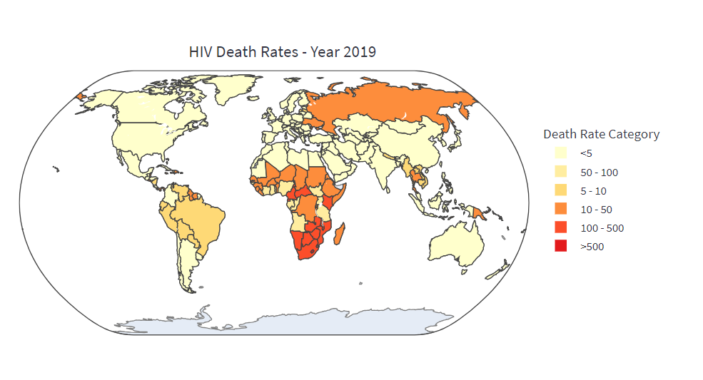

The significant impact of HIV/AIDS on public health in Sub-Saharan Africa is evident in the death rates associated with the disease. The map, in figure 2, displays the distribution of death rates globally, revealing that the majority of countries have rates below 10 deaths per 100,000 individuals. In Europe, the death rate is even lower, with less than one death per 100,000. However, in Sub-Saharan Africa, the rates are substantially higher. Most countries in southern Africa reported rates exceeding 100 deaths per 100,000 population. Notably, in South Africa, the rate surpassed 200 deaths per 100,000 individuals.

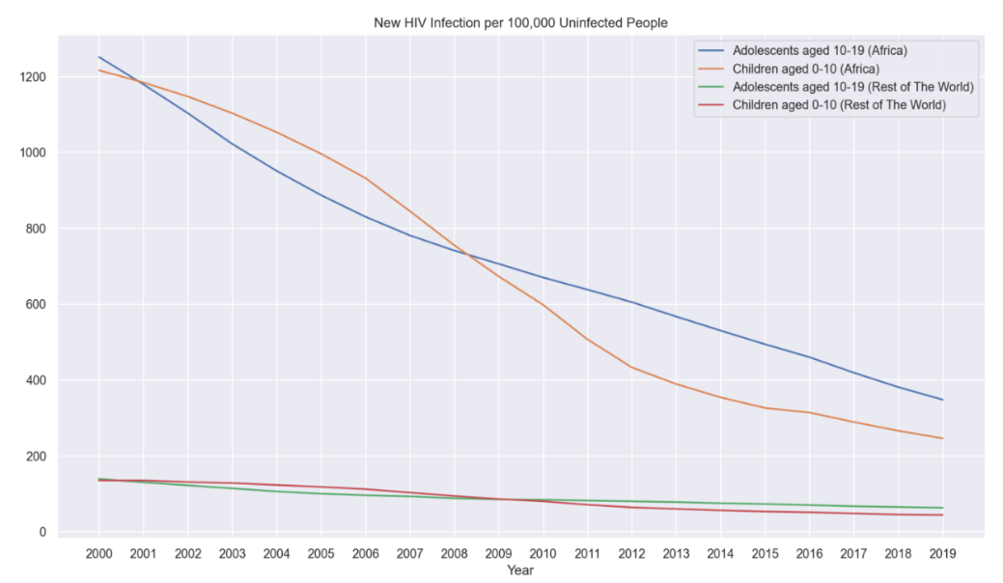

Figure 2 HIV Death Rates Per Year

Figure 3 depicts a chart illustrating the number of new HIV infections in children and adolescents. The data reveals a peak in the early 2000s, followed by a substantial decline over the past decade. Despite this overall downward trend, it is evident that African youth continue to bear a significant burden of HIV infections compared to the rest of the world. The number of infections in African youth remains relatively high, indicating that efforts to combat HIV transmission among this population need to be intensified to achieve further reductions in new infections.

Figure 3 New HIV Infection Rate per 100,000 Uninfected People

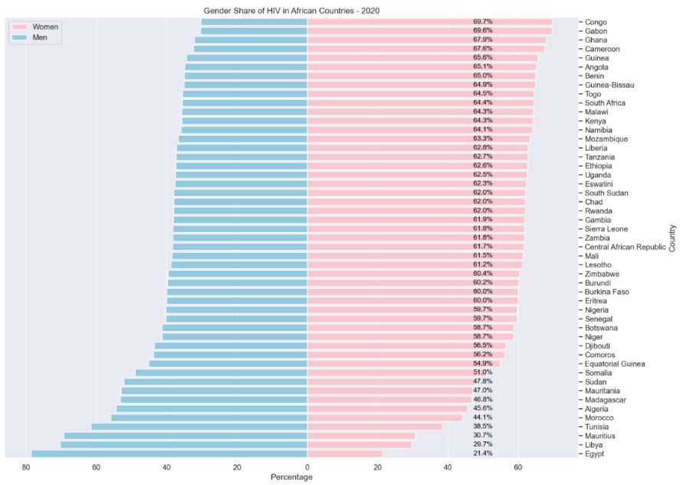Across Sub-Saharan Africa, there is a notable trend of higher HIV prevalence among women compared to men. Gender inequality and social norms contribute to the higher prevalence of HIV among females. This can be attributed to several factors, including limited participation of women in sexual decision-making and protection. Women often have less control over negotiating safe sexual practices, such as condom use, due to unequal power dynamics in relationships. Additionally, lower rates of sexual education and awareness among women compared to men further contribute to their vulnerability to HIV infection.

Figure 4 Gender Share of HIV Infection in African Countries per Year

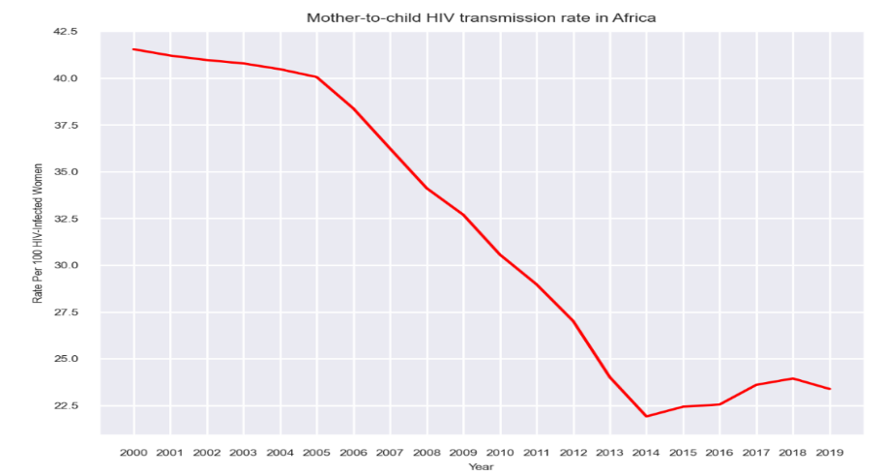

HIV is transmitted through the exchange of certain bodily fluids. Among children, sexual intercourse and needle sharing can not be a primary cause of infection. However, figure 4 shows that the HIV is more prevalent in women. Transmission of HIV in children is most likely occurring through mother-to-child transmission, which can happen during pregnancy, childbirth, or through breastfeeding. Figure 5 illustrates a drop in the mother to child infection after peaking in the early 2000s, however the rate remains high at almost 23 per 100 infected women.

Figure 5 Mother to Child HIV Transmission Rate in Africa

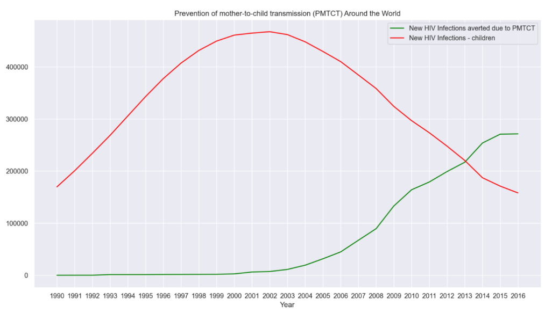

According to UNICEF, if no action is taken, approximately 15% to 45% of infants born to HIV-positive mothers are at risk of acquiring the virus. Additionally, half of the HIV-infected infants are likely to pass away before their second birthday if they do not receive treatment.

Figure 6 demonstrates the number of child infections prevented as a result of providing antiretroviral therapy (ART) to mothers.

Figure 6 Prevention of Mother-Child Transmission Around the World

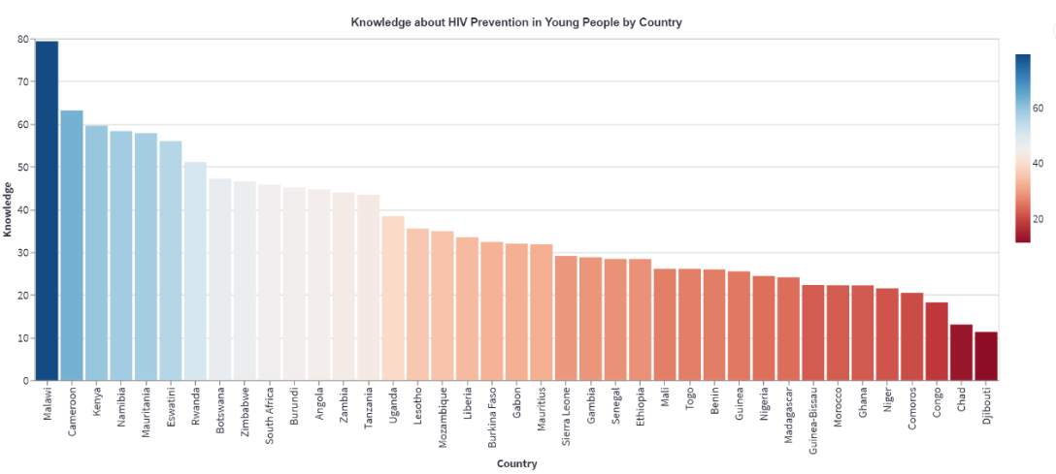

Figure 7 HIV Prevention Knowledge Among Young People in Africa

Figure 7 depicts that the majority of the percentages displayed in the chart are below 50%. This suggests a significant gap in HIV prevention knowledge among young adolescents in African countries. This highlights the urgent need for targeted interventions and educational programs to improve awareness and understanding of HIV prevention strategies among this vulnerable population.

Figure 8 Share of People (15-49 Years Old) Who Used a Condom

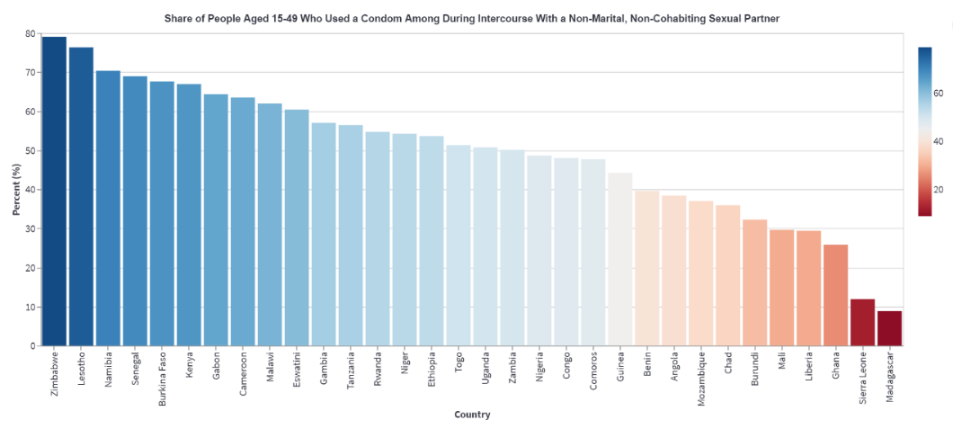Based on figure 8 depicting the share of people aged 14 to 59 in African countries who used a condom during high-risk sexual encounters, the majority of the percentages are below 60%. This indicates that a significant portion of the population engaging in high-risk sexual activity in African countries does not consistently utilize condoms for protection. The data suggests a need for increased awareness, education, and access to condoms to promote safer sexual practices.

# Recommendations

* Strengthen prevention efforts: Intensify efforts to prevent new HIV infections among adolescents and young people through targeted interventions, comprehensive sexual education programs, and increased access to preventive measures such as condoms.
* Enhance access to antiretroviral therapy (ART): Ensure universal access to ART for pregnant women living with HIV to prevent mother-to-child transmission. Strengthen healthcare systems to provide effective treatment and follow-up care for both mothers and children.
* Expand HIV testing and counseling: Increase the availability and accessibility of HIV testing and counseling services, particularly in remote and underserved areas. Encourage routine HIV testing and promote awareness of the importance of early diagnosis.
* Improve prevention knowledge and awareness: Implement comprehensive HIV prevention education programs targeting young adolescents, focusing on promoting safe sexual practices, raising awareness about HIV transmission modes, and challenging myths and misconceptions.
* Increase condom usage: Launch campaigns to promote consistent and correct condom use among populations engaging in high-risk sexual behavior. Enhance availability and accessibility of condoms through distribution programs and public health facilities.

# References

1. Dwyer-Lindgren, L., Cork, M.A., Sligar, A. et al. Mapping HIV prevalence in sub-Saharan Africa between 2000 and 2017. Nature 570, 189–193 (2019). <https://doi.org/10.1038/s41586-019-1200-9>
2. Kharsany AB, Karim QA. HIV Infection and AIDS in Sub-Saharan Africa: Current Status, Challenges and Opportunities. Open AIDS J. 2016 Apr 8;10:34-48. doi: 10.2174/1874613601610010034. PMID: 27347270; PMCID: PMC4893541.
3. Liu, H., Su, Y., Zhu, L., Xing, J., Wu, J., & Wang, N. (2014). Effectiveness of ART and condom use for prevention of sexual HIV transmission in serodiscordant couples: A systematic review and meta-analysis. PLOS ONE, 9(11), e111175. <https://doi.org/10.1371/journal.pone.0111175>
4. Newell, Marie-Louisea; Brahmbhatt, Heenab; Ghys, Peter Dc. Child mortality and HIV infection in Africa: a review. AIDS 18():p S27-S34, June 2004.
5. Pandey, A., & Galvani, A. P. (2019). The global burden of HIV and prospects for control. The Lancet HIV, 6(12), E809-E811. doi: 10.1016/S2352-3018(19)30230-9
6. UNICEF. (2021). The State of the World's Children 2021. Retrieved from <https://www.unicef.org/reports/state-worlds-children-2021>
7. Yudkin, Patricia La; Burger, Elsie Hb; Bradshaw, Debbiec; Groenewald, Pamc; Ward, Alison Ma; Volmink, Jimmyd,e. Deaths caused by HIV disease under-reported in South Africa. AIDS 23(12):p 1600-1602, July 31, 2009. | DOI: 10.1097/QAD.0b013e32832d4719